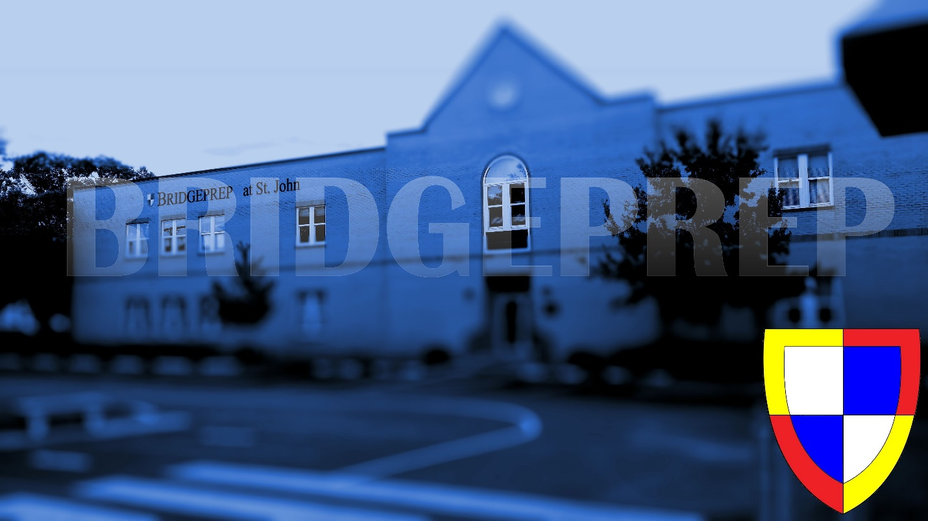OPEN HOUSE

BridgePrep Academy of South Tampa

WHy BridgePrep?

aDVANCE ED ACCREDITED

EXTENDED LANGUAGE PROGRAM

TECHNOLOGY RICH ENVIRONMENT

TUITION FREE PUBLIC CHARTER SCHOOL

MONDAY, FEBRUARY 24th

ALL GRADES k-8 5pm to 6pm

Call office for ZOOM LINK

**What You Can Expect At Open House**

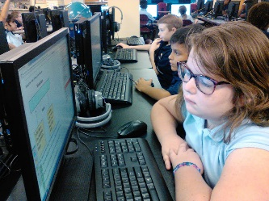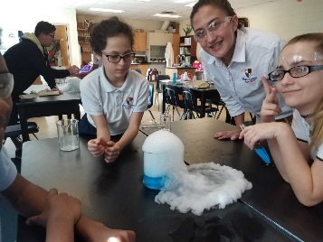**VIRTUAL Tour of our Campus**

**Learn about Curriculum**

**Meet Teachers and Administrators**

**Now Taking Applications For the 2021 – 2022**

**School Year!!Bridgepreptampa.com Phone – (813)256 - 5652**